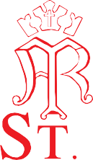
Main Street, Aston-le-Walls,
Daventry, Northamptonshire
NN11 6UF
T: 01295 660258
E: head@stmarys-pri.northants-ecl.gov.uk
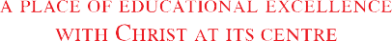 W: www.stmarysrc-astonlewalls.co.uk

Dear Parent/Guardian,

Free School Milk

Free milk is available for all children aged under five in school, funded by the UK government.
In our school, this milk is provided by Cool Milk, the UK’s leading school milk supplier.

We will register your child for their free school milk on your behalf by providing Cool Milk with your child’s name and date of birth.

Shortly before your child turns five, you will be offered the opportunity to pay a subsidised rate for your child to continue to receive milk.

All information handled by the Cool Milk group is processed in accordance with the Data Protection Act 1998. All personal information is securely stored on Cool Milk’s UK servers, and is never passed on to third parties without your permission.

Please let me know if you would prefer us not to register your child for free school milk.

Yours sincerely

Mrs Laura Concannon
Head Teacher

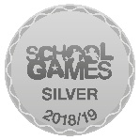
Head Teacher: Mrs L Concannon
Chair of Governors: Mrs R Iley

