Your task:
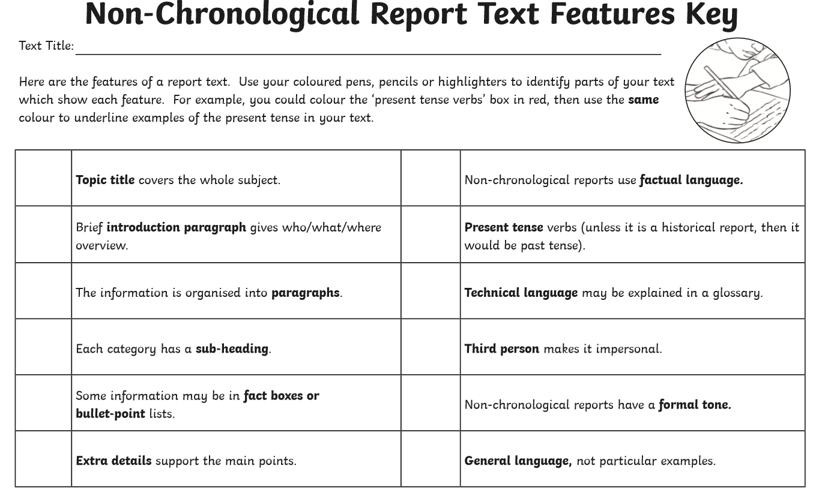
Like you did with the molluscs activity, you are going to identify the features of a non-chronological report in this report about Mars. Read through the text and use coloured pencils/pens and the non-chronological features report key to help you highlight and identify the different features. (You could also draw arrows to and annotate the different parts - e.g. Title, Introduction, Glossary etc.).

