Contrasting Window Images

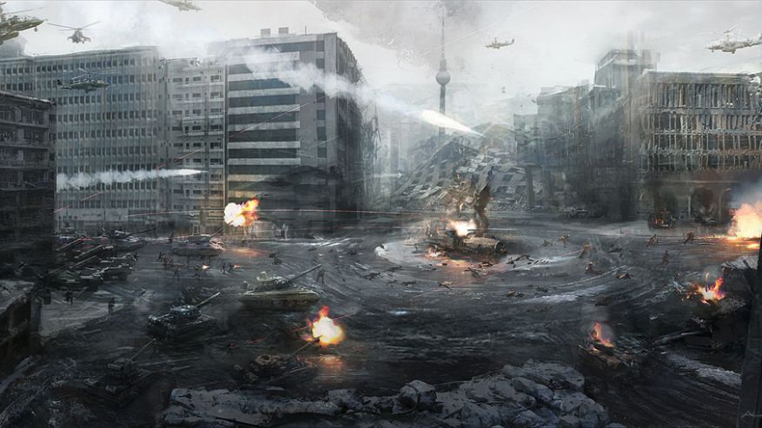

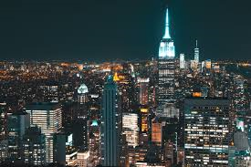[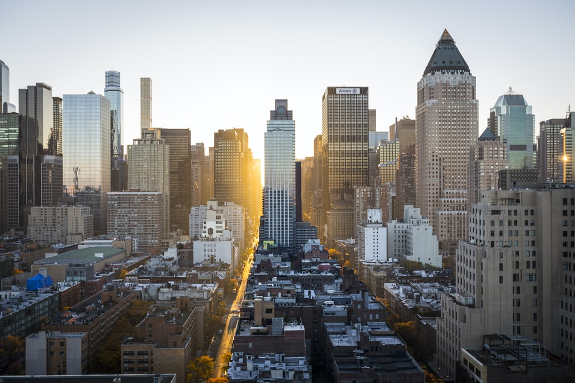](https://www.google.co.uk/url?sa=i&url=https%3A%2F%2Funsplash.com%2Fs%2Fphotos%2Fcity&psig=AOvVaw32rVDiaBIcfY-yi_3N4kgK&ust=1593684003224000&source=images&cd=vfe&ved=0CAIQjRxqFwoTCLj26Njlq-oCFQAAAAAdAAAAABAE)