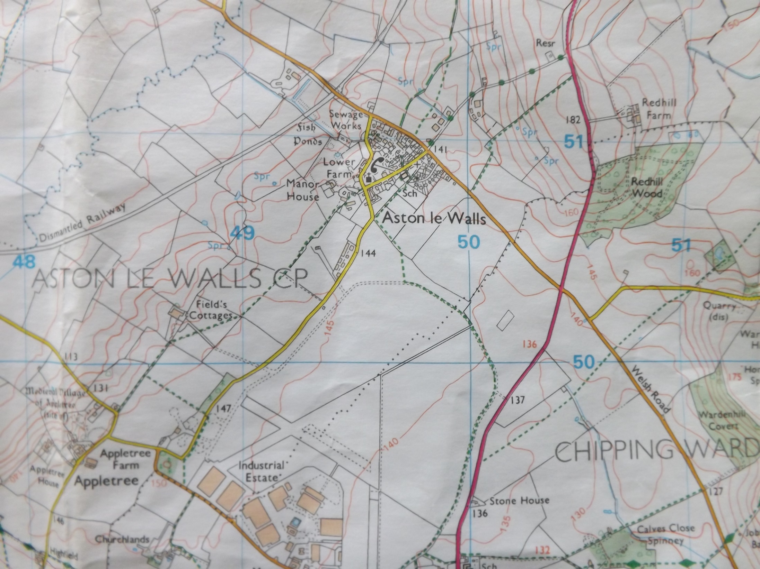

**Extension:**

Can you find and label the following things?

* The old airfield.
* The old railway.
* The deserted medieval village of Appletree.
* Our school.

