Contrasting Images - Now and Then Two Star

Describe what the ‘now’ and ‘then’ scenes are like, using the senses below to help you. Try to create two sentences for each sense. Make sure that you include a noun phrases and a fronted adverbial in each of your sentences. If you really want to push yourself, try to use similes, alliteration, personification and metaphors.
E.g. Sights: On the road, shiny, silver cars speed by like sprinters in a race.
(fronted adverbial) (noun phrase) (simile)
Now
Sights:
- _________________________________________
- _________________________________________
Sounds:
- _________________________________________
- _________________________________________
Smells:
- _________________________________________
- _________________________________________
Tastes:
- _________________________________________
- _________________________________________
Emotions:
- _________________________________________
- _________________________________________
Touch::
- _________________________________________
- _________________________________________

Then
Sights:
- _________________________________________
- _________________________________________
Sounds:
- _________________________________________
- _________________________________________
Smells:
- _________________________________________
- _________________________________________
Tastes:
- _________________________________________
- _________________________________________
Emotions:
- _________________________________________
- _________________________________________
Touch:
- _________________________________________
- _________________________________________

Now
Sights:
- _________________________________________
- _________________________________________
Sounds:
- _________________________________________
- _________________________________________
Smells:
- _________________________________________
- _________________________________________
Tastes:
- _________________________________________
- _________________________________________
Emotions:
- _________________________________________
- _________________________________________
Touch:
- _________________________________________
- _________________________________________

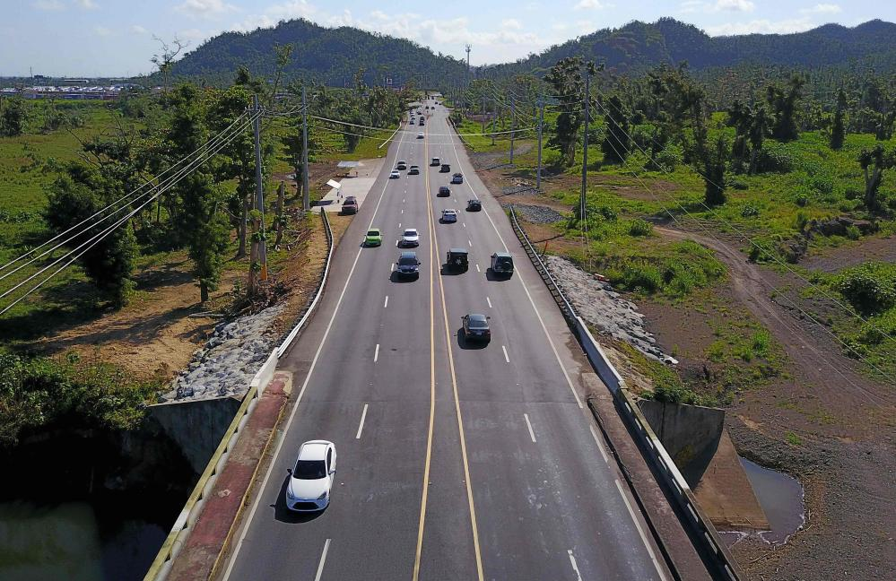
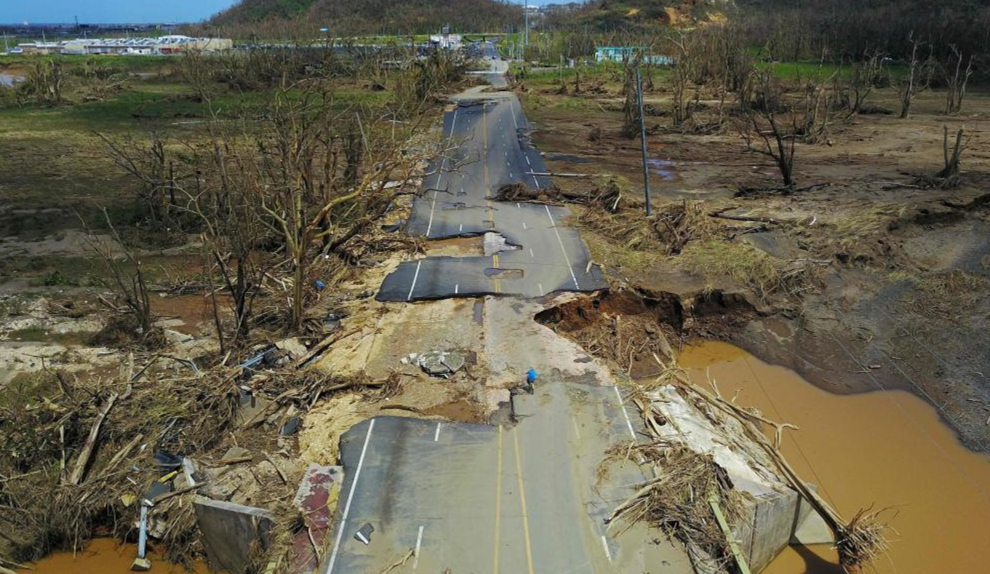
Then
Sights:
- _________________________________________
- _________________________________________
Sounds:
- _________________________________________
- _________________________________________
Smells:
- _________________________________________
- _________________________________________
Tastes:
- _________________________________________
- _________________________________________
Emotions:
- _________________________________________
- _________________________________________
Touch:
- _________________________________________
- _________________________________________

