Maths Worksheet Year 5 - Tuesday
Challenge A
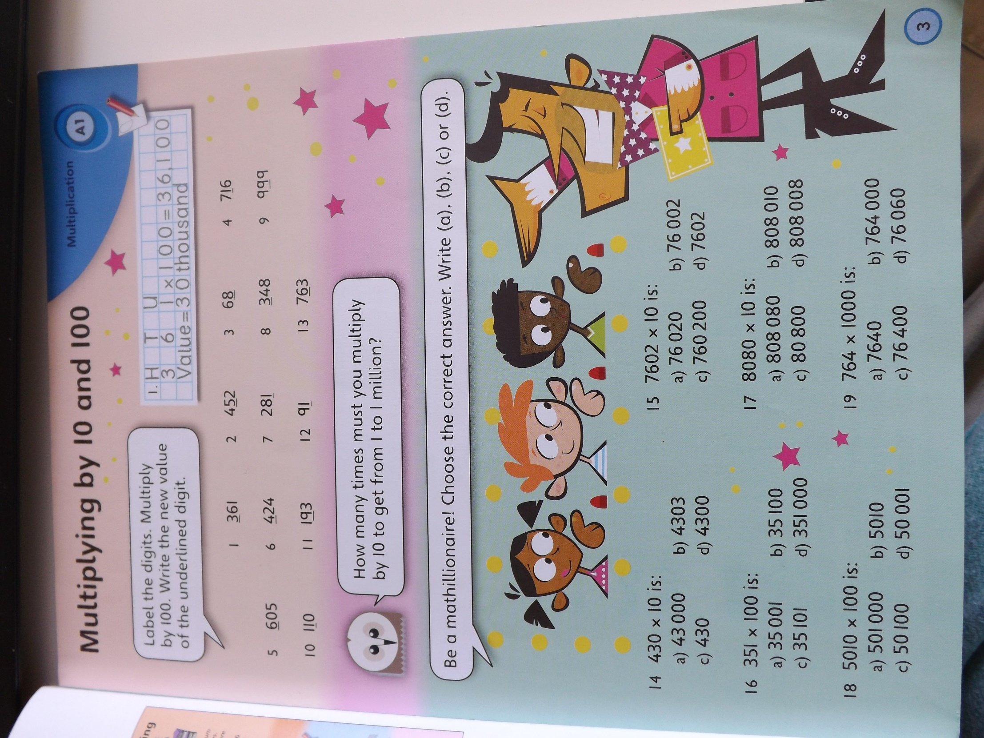
Challenge B
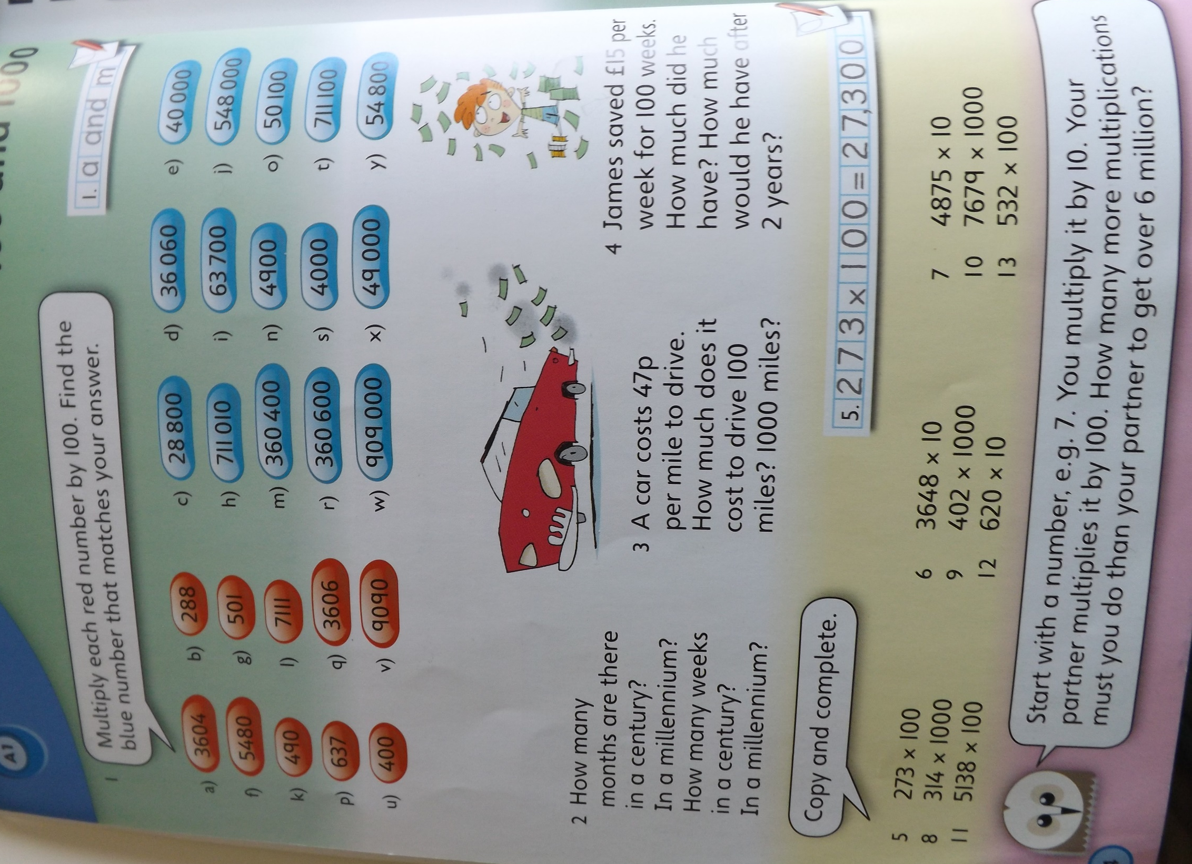
Challenge C

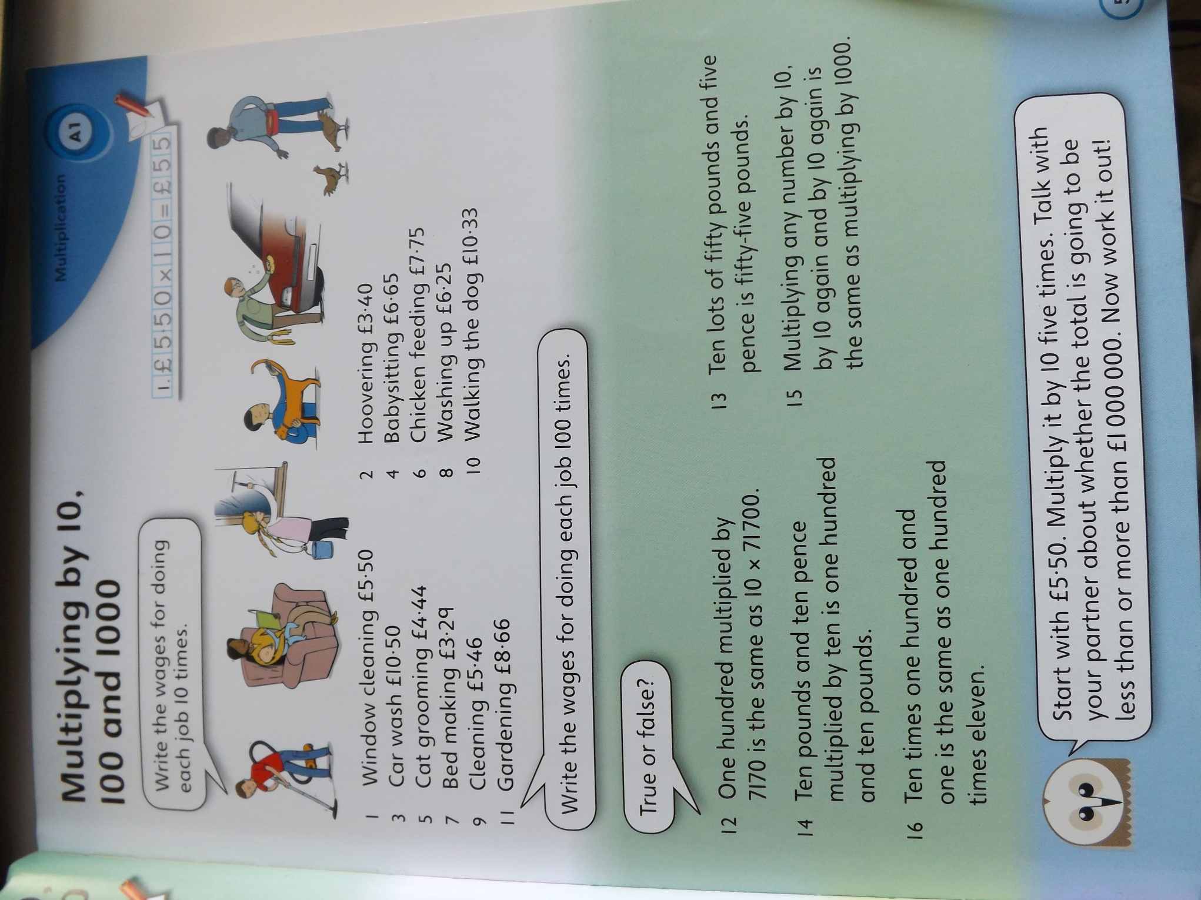
Answers
Unfortunately there is no answer book for this activity,

