Mulberry Class Home Learning Week Beginning 15/06/2020
Outlined below are activities for the children in Mulberry Class to complete over the week. At the end of the document are also two topic activities for the children to complete. In addition to these, please ensure that your child reads regularly during the week.
If you are unable to print the documents out, please get the children to complete the work in the exercise books provided by the school.
Monday:
English:
Today you will be looking at some ‘twisted’ fairy tales; these are fairy tales told from the perspective of the traditional villain in the story, explaining their viewpoint on the events which took place. Watch some of the videos on the PowerPoint or go to the video links below:
Cinderella is Seriously So Annoying https://www.youtube.com/watch?v=upF_AAR4hmc
Trust Me, Jack’s Beanstalk Stinks
https://www.youtube.com/watch?v=nT6gdr3RXTM
Honestly, Red Riding Hood Was Rotten
https://www.youtube.com/watch?v=COQQBh05J6U
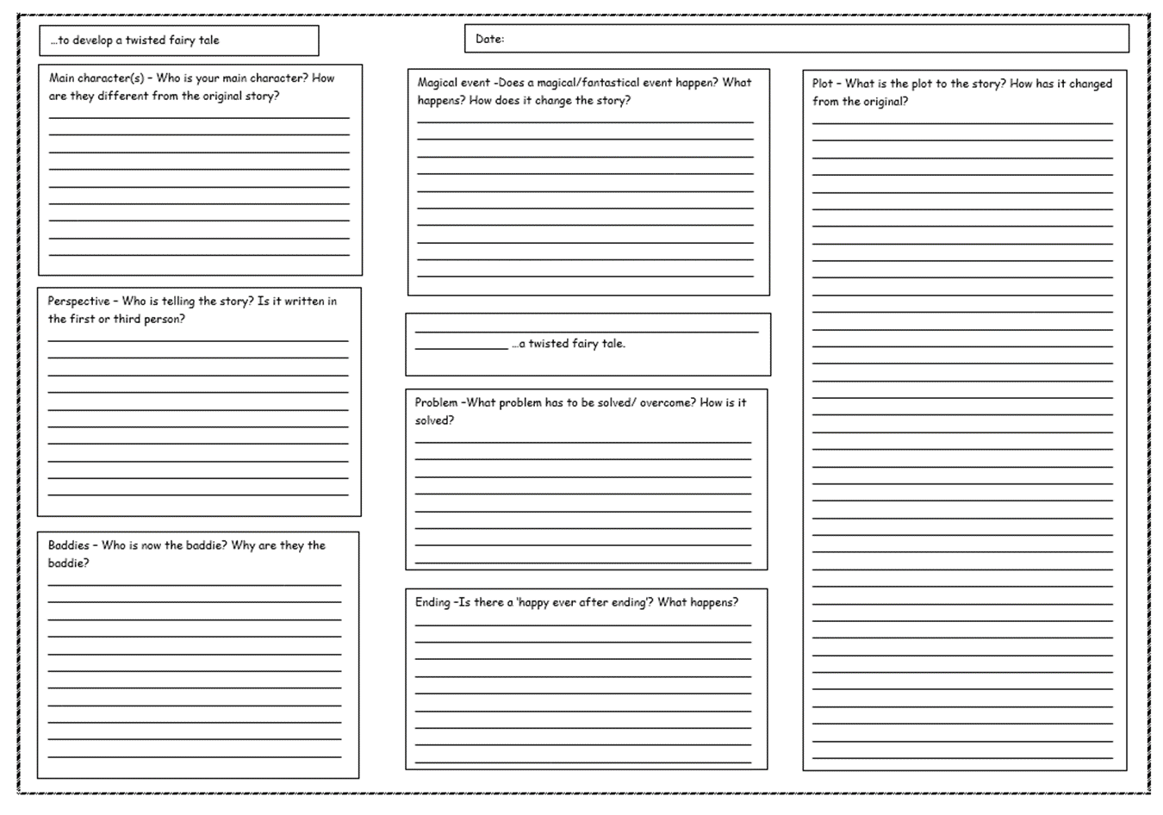
Think about the different titles of ‘twisted’ fairy tales on the PowerPoint and how they would change the telling of the story. You are then going to develop your own ‘twisted’ version of a fairy tale. You could tell the story from the perspective of one of the objects in the story, like in ‘The Pea and the Princess’, or choose to write the story from the villain’s perspective, like the ones you have seen on the PowerPoint. Complete a plan for your own twisted fairy tale, using the planning grid.

Mathematics:
- Practise the times tables that match the current level of the ‘Multiples Marathon’ that you are on.
- Complete the following sums to practice your written calculation skills:
- 201 + 68 + 98 =
- 502 - 399 =
- 2.96 + 0.501=
- 10.05 – 1.25 =
- 253 x 9 =
- 2351 x 22 =
- 1060 ÷ 5 =
- Look at Monday’s Maths PowerPoint about calculating the area of squares and rectangles. Go through the slides and complete the examples. Complete the challenge on the maths worksheet you feel comfortable with – remember Challenge A is easier, Challenge B is middle and Challenge C is the hardest.
Tuesday:
English:
Today you are going to practice uplevelling sentences to help you when you come to write your own fairytale later this week. Go through Tuesday’s PowerPoint about uplevelling sentences and have a go at the examples on the slides. Once you have done this complete the ‘Cinderella Up Levelling Setences’ activity. You can make your challenge easier or harder by completing the star level you are comfortable with:
- One star: For each sentence, first, create expanded noun phrases. Next, add a fronted adverbial.
- Two star: For each sentence, first, create expanded noun phrases. Next, add a fronted adverbial. Finally, add a relative pronoun/clause.
- Three star: For each sentence, first, create expanded noun phrases. Next, add a fronted adverbial. Finally, add a relative pronoun/clause. Ask yourself: Could I add a subordinate clause at the end?
Remember - sometimes you may not be able to include all of the features in each sentence, as it may not make sense!

Mathematics:
- Practise the times tables that match the current level of the ‘Multiples Marathon’ that you are on.
- Complete the following sums to practice your written calculation skills:
- 10 985 + 25 + 205.3=
- 9085 – 7754 =
- 3.6 + 11.03 =
- 0.8 – 0.563 =
- 253 x 36 =
- 3005 x 25 =
- 4710 ÷ 6 =
- Look at Tuesday’s Maths PowerPoint about how to calculate the area of compound shapes. Go through the slides and complete the examples. Complete the challenge on the maths worksheet you feel comfortable with – remember Challenge A is easier, Challenge B is middle and Challenge C is the hardest.
Wednesday:
English:
Today you will be planning your own version of a twisted fairy tale from start to finish. Go through the PowerPoint for Wednesday, which explains how you should plan out your story on a story plan/grid and then go on to begin to plan your story. You can use either the planning grid or the mountain to help you do this. Make sure that you look back at your work on Monday, as this is where you should have started with your ideas for a twisted version of a traditional fairy tale.

Mathematics:
- Practise the times tables that match the current level of the ‘Multiples Marathon’ that you are on.
- Complete the following sums to practice your written calculation skills:
- 101 235 + 36 900 + 23 =
- 9006 - 7998 =
- 1.2 + 13.39 =
- 0.25 – 0.104 =
- 2351 x 7 =
- 7050 x 31 =
- 5080 ÷ 8 =
- Look at Wednesday’s Maths PowerPoint about how to estimate the area of irregular shapes. Go through the slides and complete the examples. Year 5, complete the challenge on the maths worksheet you feel comfortable with – remember one star is easier, two stars is middle and three stars is the hardest. Year 4, complete the challenge you feel comfortable with - remember Challenge A is easier, Challenge B is middle and Challenge C is the hardest.
There is an extension activity if you want to challenge yourself.
Thursday:
English:
Today you will be writing the opening for your own fairy tale. Go through the English PowerPoint for Thursday and re-read some of openings to the stories you have been looking at to give you some ideas for your own. When you have done this look carefully at the instructions for writing your opening, making sure that you introduce the main character and setting and start the build up to your dilemma/problem. You can use the word mats to help you.
When you have completed your opening, make sure that you check it against the writing checklist for your year group and that you re-read and edit your work, adding in punctuation or features you may have missed.
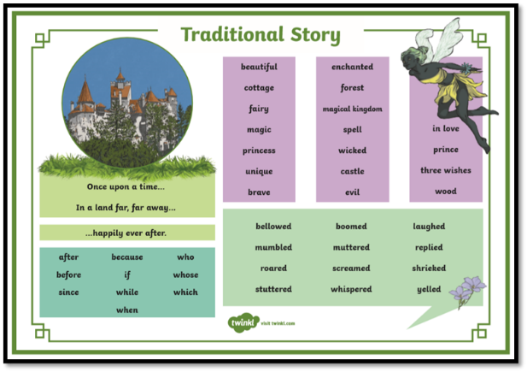
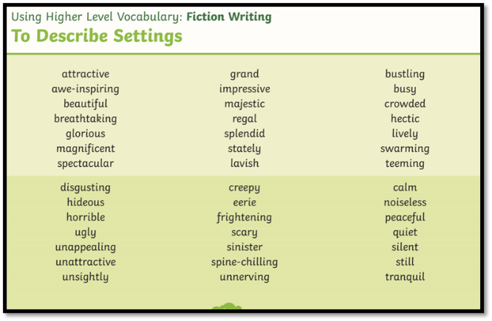

Mathematics:
- Practise the times tables that match the current level of the ‘Multiples Marathon’ that you are on.
- Complete the following sums to practice your written calculation skills:
- 10 050 + 1805 =
- 20 569 – 19 583 =
- 0.89 + 22.5 =
- 21 – 0.69 =
- 1985 x 4 =
- 563 x 33 =
- 2958 ÷ 3 =
- Look at Thursday’s Maths PowerPoint about how to calculate volume and capacity. Go through the slides and complete the examples. Complete the challenge on the maths worksheet you feel comfortable with – remember Challenge A is easier, Challenge B is middle and Challenge C is the hardest.
Friday:
English:
Today you will be writing the build-up and dilemma for your story. Go through Friday’s PowerPoint which gives you examples of the build-up and dilemmas for the other twisted fairy tales we have read. Look at the example story of Cinderella from the perspective of the glass slipper – can you identify what is missing from the text? When you have done this, you can start your writing. Remember to include the following things:
- Build-up - describe your characters in more detail and how they meet in the story.
- Introduce the problem – explain what the problem is, making sure that you include lots of action and dialogue between the characters.
You can use the word mats from last lesson to help you. Make sure that you include dialogue between the characters and that you use the rules for punctuating direct speech which you practiced in the lesson last week.
When you have completed your work, make sure that you check it against the writing checklist for your year group and that you re-read and edit it, adding in punctuation or features you may have missed.
Mathematics:
- Practise the times tables that match the current level of the ‘Multiples Marathon’ that you are on.
- Complete the following sums to practice your written calculation skills:
- 25.23 + 0.56 + 908
- 1 526 366 – 299 456 =
- 896 + 2.56 =
- 9.1 – 9.025 =
- 3256 x 3 =
- 7805 x 19 =
- 6252 ÷ 4 =
- Look at Friday’s Maths PowerPoint about how to convert between seconds, minutes and hours. Go through the slides and complete the examples. Complete the challenge on the maths worksheet you feel comfortable with – remember Challenge A is easier, Challenge B is middle and Challenge C is the hardest.

Topic work:
Task 1 – Geography:
Today you will be looking at how maps show how a location changes over time. Go through ‘Topic PowerPoint 1’, which explains how old pictures and maps can tell us what a place may have looked at in the past and gives you some history about the village of Aston le Walls. When you have done this, complete Topic Activity 1 which is about how the village of Aston le Walls and the area around it has changed by looking at a map from 1899 and a modern Ordinance Survey Map.

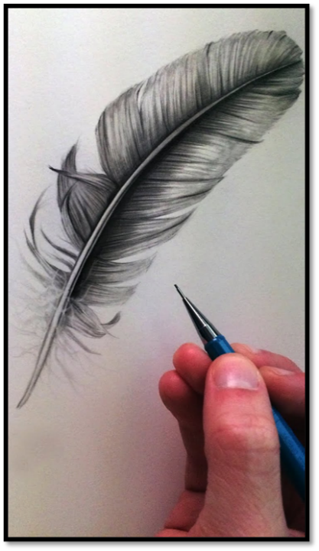
Task 2 – Art:
Over the next few topic tasks you will be looking birds and how to draw them. To begin with you will be learning about feathers. Go through ‘Topic PowerPoint 2’ which tells you about the different parts of a bird’s feather and shows you some of the prettiest bird feathers – those belonging to the birds of paradise. When you have done this, watch the two videos which explain how to draw a feather. You will need to draw your feather in black and white on a piece of A4 paper. The drawing must be enlarged to fill the paper and include all of details you would expect to see when looking at a real bird’s feather.

Extension:
Native Americans are famous for the use of feathers in their traditional clothing. Find out more about how feathers are used in this culture.

