Contrasting Images - Now and Then One Star
Describe what the ‘now’ and ‘then’ scenes are like, using the senses below to help you. Try to create one sentence for each sense. Make sure that you include a noun phrases and a fronted adverbial in each of your sentences. If you really want to push yourself, try to use similes and alliteration.
E.g. Sights: On the road, shiny, silver cars speed by like sprinters in a race.
(fronted adverbial) (noun phrase) (simile)
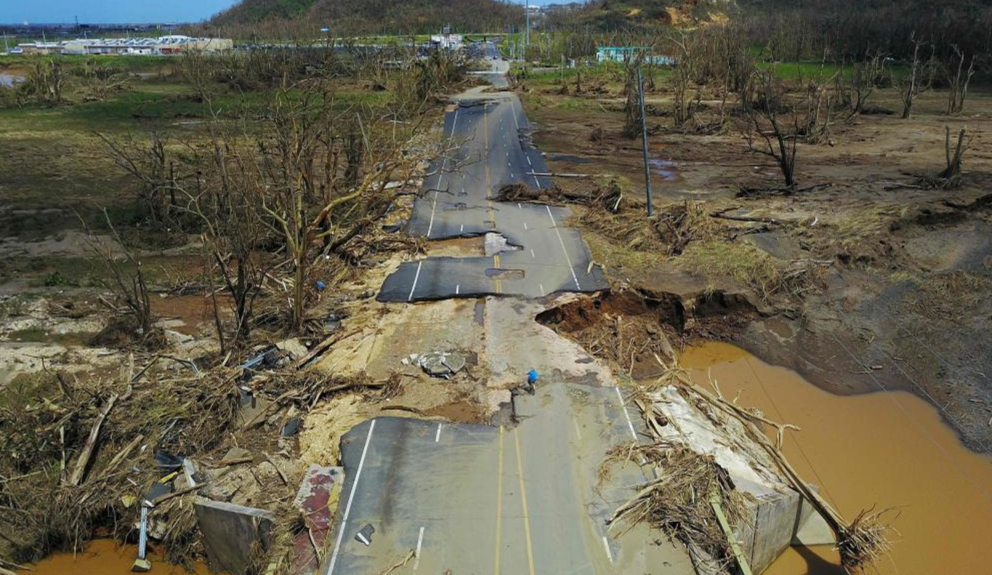
Now
Sight:
__________________________________________
Sound:
__________________________________________
Smell:
__________________________________________
Taste:
__________________________________________
Emotion:
__________________________________________
Touch:
__________________________________________
Then
Sight:
__________________________________________
Sound:
__________________________________________
Smell:
__________________________________________
Taste:
__________________________________________
Emotion:
__________________________________________
Touch:
__________________________________________

Now
Sight:
__________________________________________
Sound:
__________________________________________
Smell:
__________________________________________
Taste:
__________________________________________
Emotion:
__________________________________________
Touch:
__________________________________________

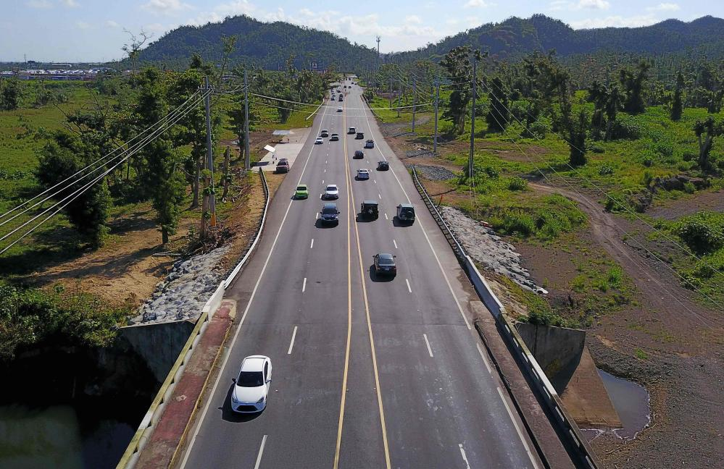
Then
Sight:
__________________________________________
Sound:
__________________________________________
Smell:
__________________________________________
Taste:
__________________________________________
Emotion:
__________________________________________
Touch:
__________________________________________

