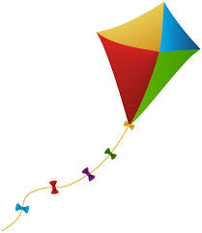Ideas Activity Sheet

Kites

How do kites fly? Try to explain how kites are able to fly.

_____________________________________________________________________________________________________________________________________________________________________________________________________________________________________________________________________________________________________________________________________________________________________________________________________________________________________________________________________________________________________________________________

What different materials are kites made out of? Why is this?

_________________________________________________________________________________________________________________________________________________________________________________________________________________________________________________________________________________________________________________________________________________________________________________________________________________________________________________________________________

What different shapes are kites? Draw some.

Draw and label the different parts of a kite. Try and explain the job of each part.