Maths Worksheet Year 5 – Thursday
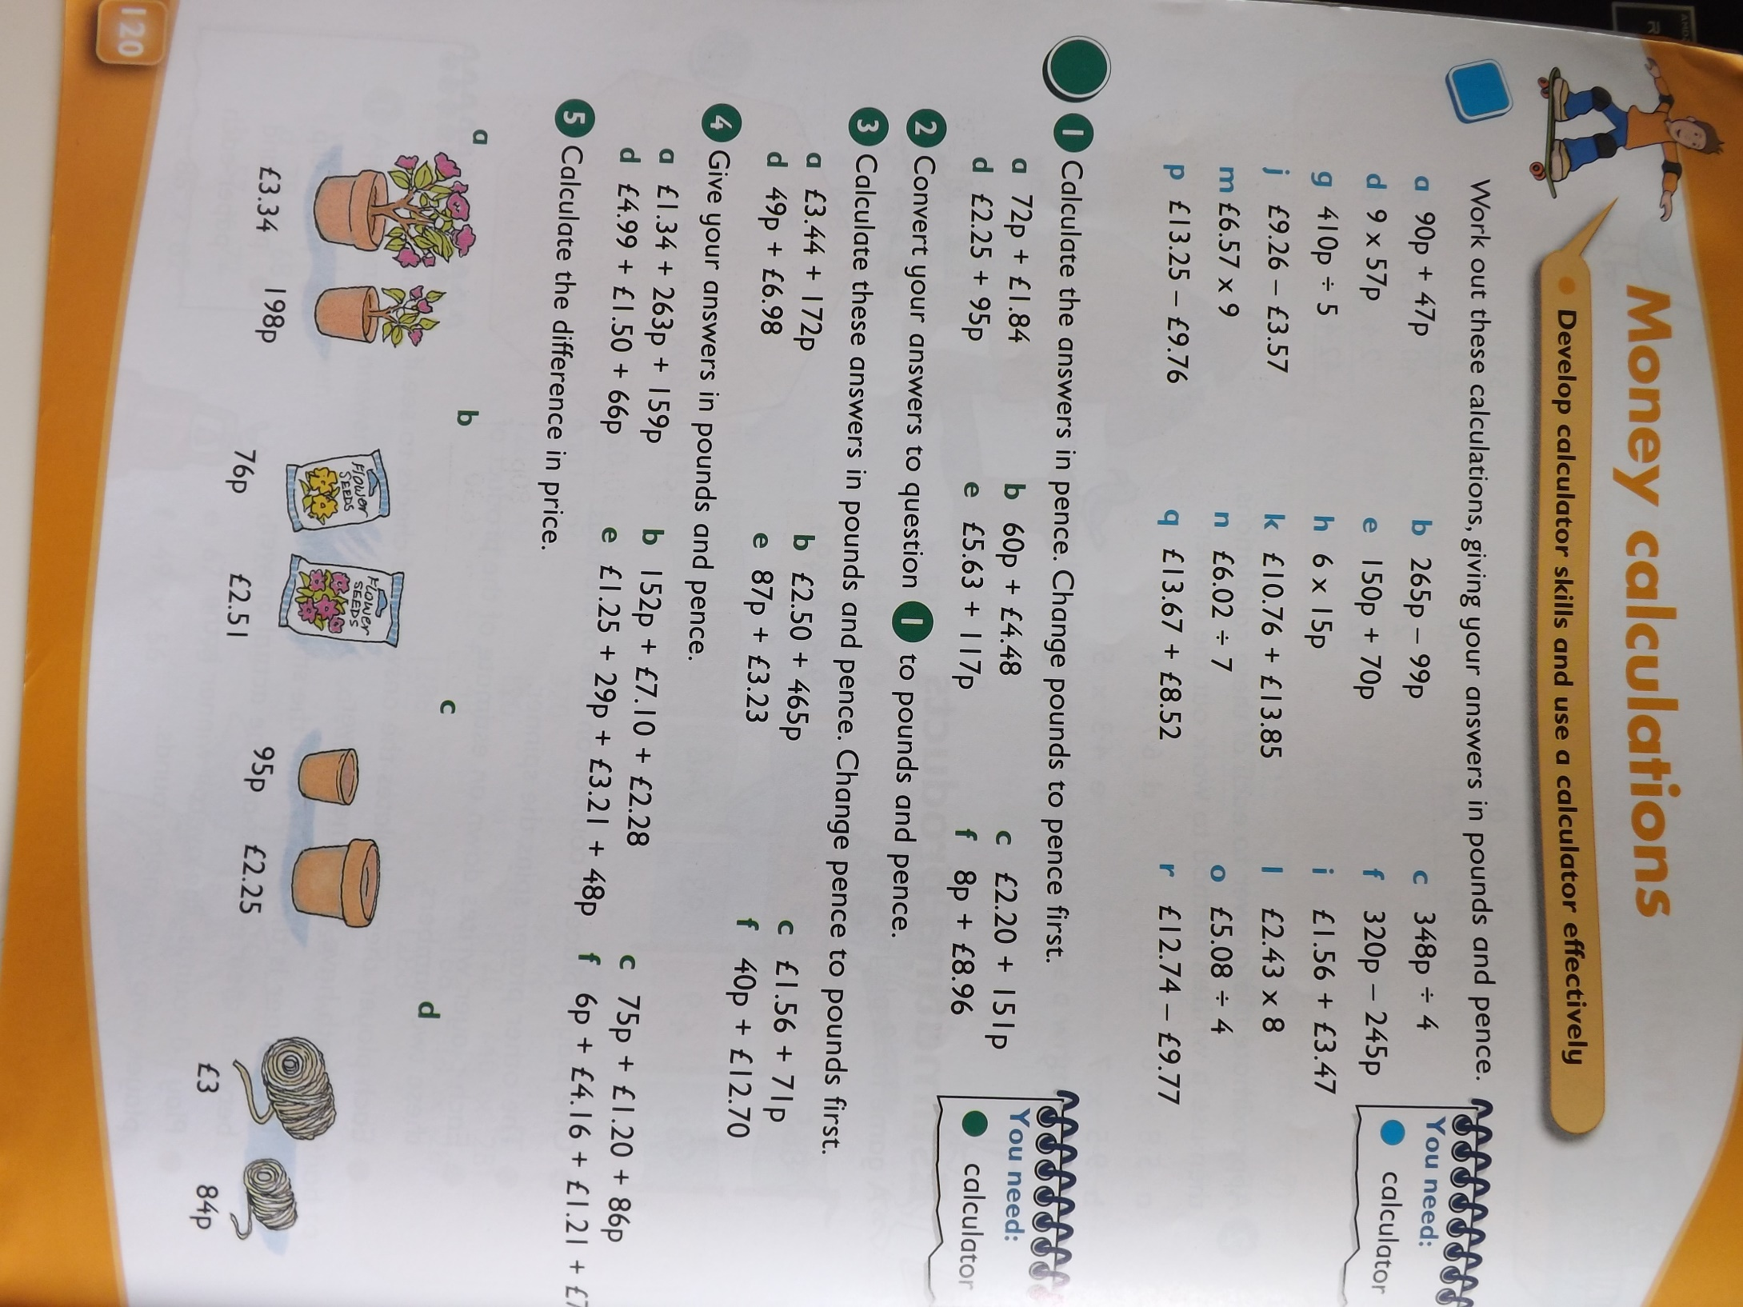
B
A

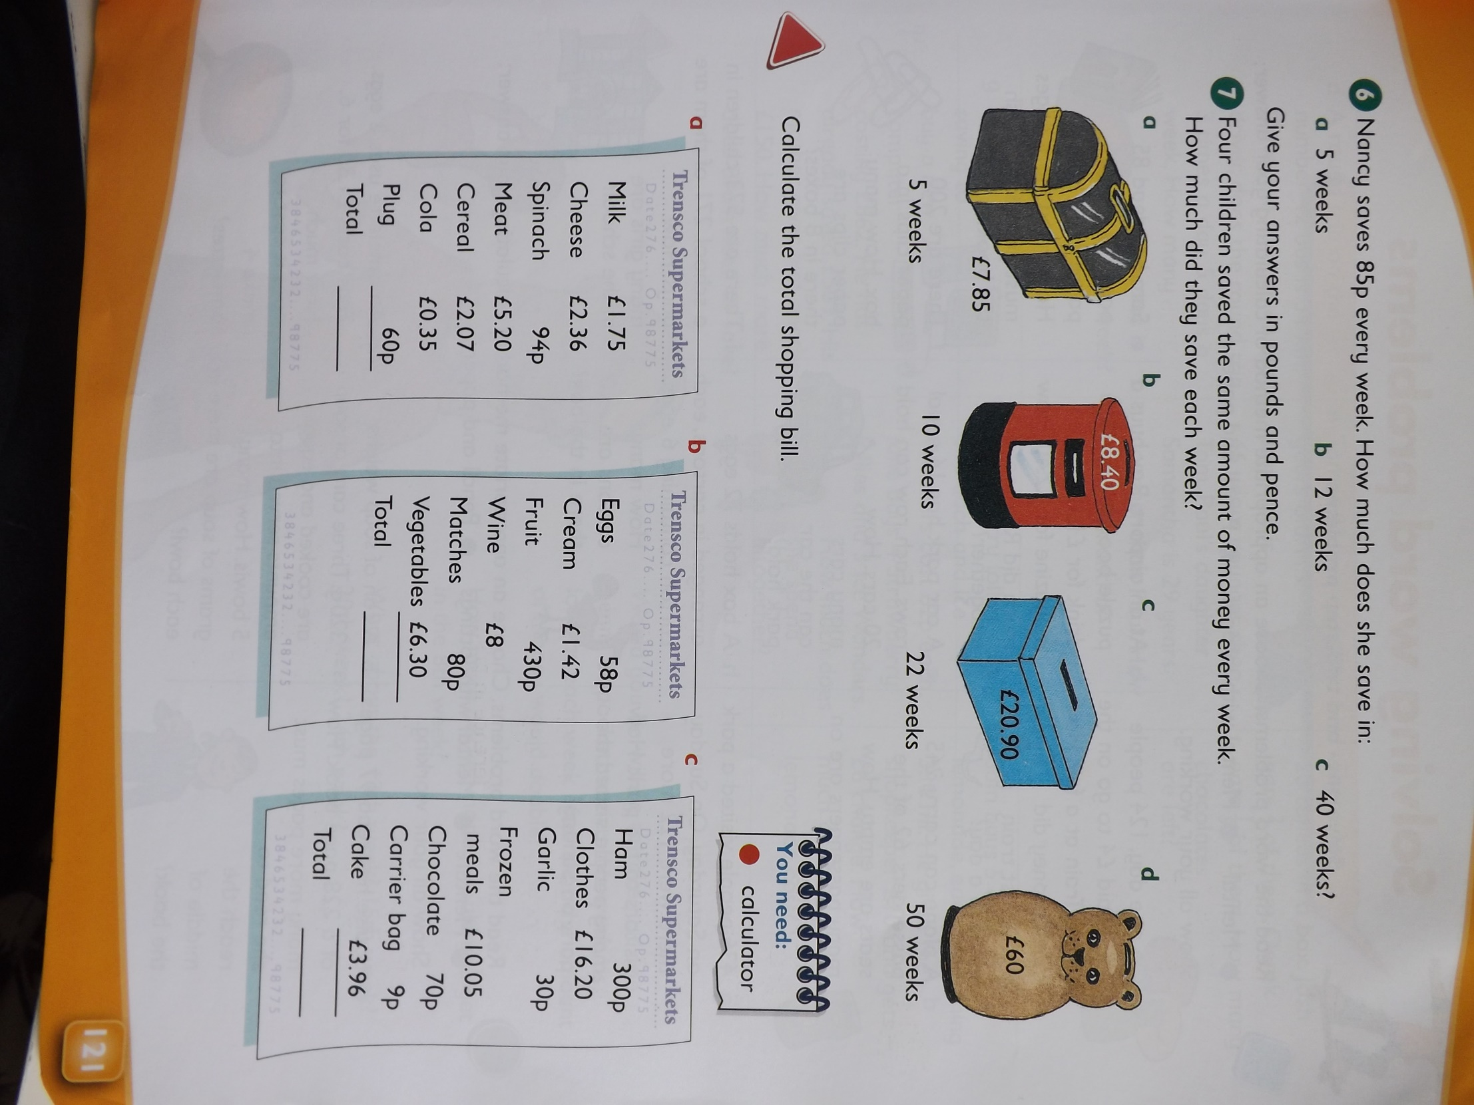
C

Answers:
Unfortunately there is no answer sheet available for this activity.

