[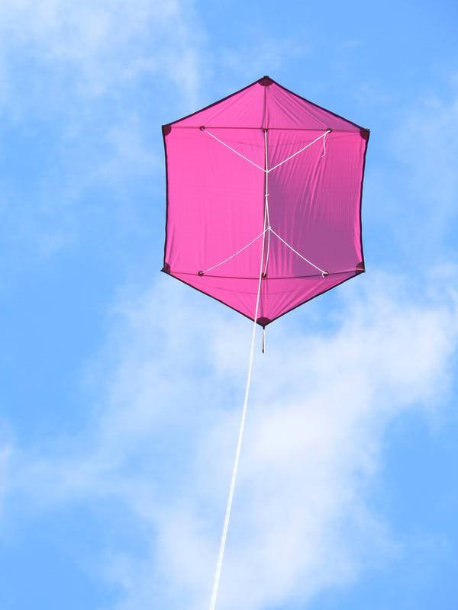](https://www.google.com/url?sa=i&url=https%3A%2F%2Fcommons.wikimedia.org%2Fwiki%2FFile%3ARokkaku.jpg&psig=AOvVaw1l-_3RyxkkfmfQTFg5pj1K&ust=1593534225060000&source=images&cd=vfe&ved=0CAIQjRxqFwoTCMjav923p-oCFQAAAAAdAAAAABAK)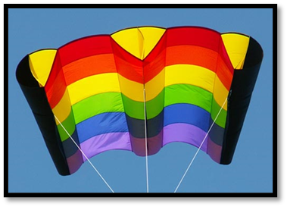[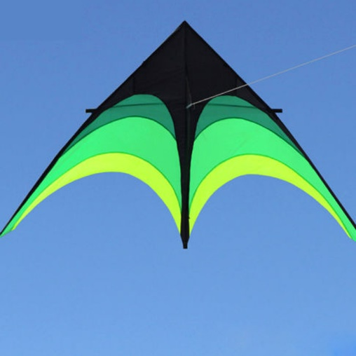](https://www.google.com/url?sa=i&url=https%3A%2F%2Fwww.aliexpress.com%2Fitem%2F32700296576.html&psig=AOvVaw1KyzW3K0W_0n9p61jokyRT&ust=1593534309058000&source=images&cd=vfe&ved=0CAIQjRxqFwoTCIDvxYW4p-oCFQAAAAAdAAAAABAK)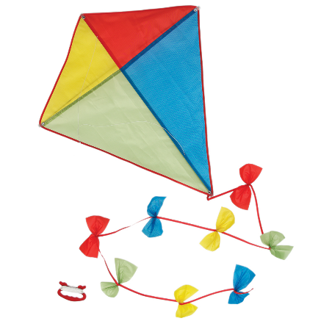**Kite Shapes -Two Star**

Name of kite:______________________________________

What country first designed this shape of kite?

________________________________________________________________________________________________________________________________________________

What are the benefits of this shape of kite?

___________________________________________________________________________________________________________________________________________________________________________________________________________________________________________________

Name of kite:______________________________________

What makes this different to other types of kites?

________________________________________________________________________________________________________________________________________________

What are the benefits of this shape of kite?

___________________________________________________________________________________________________________________________________________________________________________________________________________________________________________________

Name of kite:______________________________________

Where does this kite gets its name from?

________________________________________________________________________________________________________________________________________________

What are the benefits of this shape of kite?

___________________________________________________________________________________________________________________________________________________________________________________________________________________________________________________

Name of kite:______________________________________

Why is this kite so popular?

________________________________________________________________________________________________________________________________________________

What are the benefits of this shape of kite?

___________________________________________________________________________________________________________________________________________________________________________________________________________________________________________________